

300mm

Tensile load for 1D P=1000N

Radius of beam r=15mm

Bending load also for 3D P=1000n



A cantilever beam is subjected to a tensile load and is also analyzed for bending. The beam has the following specifications:

* **Applied Load (P):** 1000 N, applied along the **x-axis** (tensile direction)
* **Beam Length (L):** 300 mm
* **Beam Cross-Section Radius (R):** 15 mm (circular cross-section)
* **Material:** Structural Steel
  + **Young’s Modulus (E):** *Use standard value for structural steel*
  + **Poisson’s Ratio (ν):** *Use standard value for structural steel*

**Objectives:**

1. **1D Tensile Load Analysis:**
   * Find the **maximum tensile stress**
   * Find the **total deformation** (elongation)
2. **3D Bending Load Analysis (Cantilever Configuration):**
   * Treat the load as applied at the free end, perpendicular to the beam z or -y- axis (for bending)
   * Find the **maximum bending stress**
   * Find the **total deformation** (tip deflection)

**Expected Results:**

Provide numerical values for:

* **Maximum Stress** (in MPa or N/mm²)
* **Total Deformation** (in mm)  
  results put the screenshots from static structures to results.  
    
  Step 1



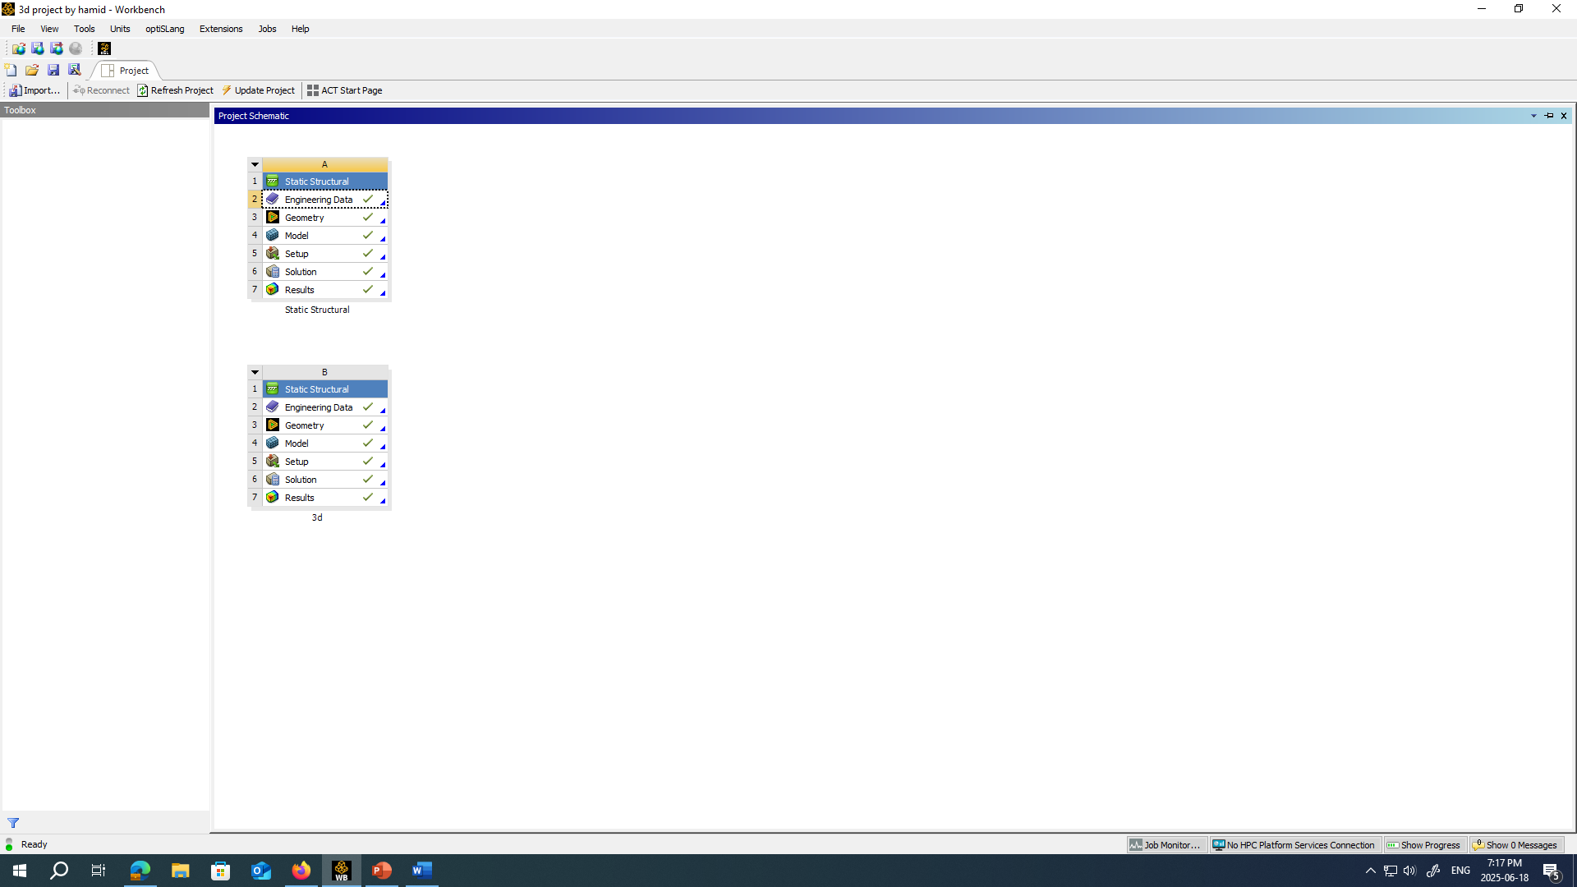

2nd step choose material  
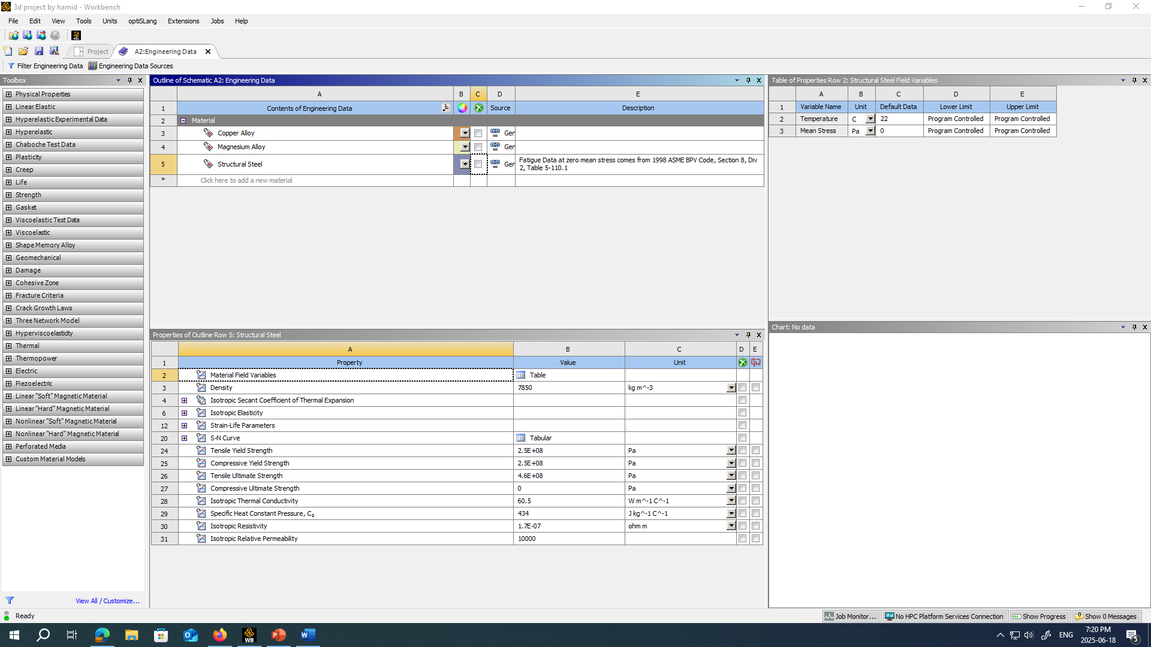

Step 3 Imaginary Geometry of 1D  
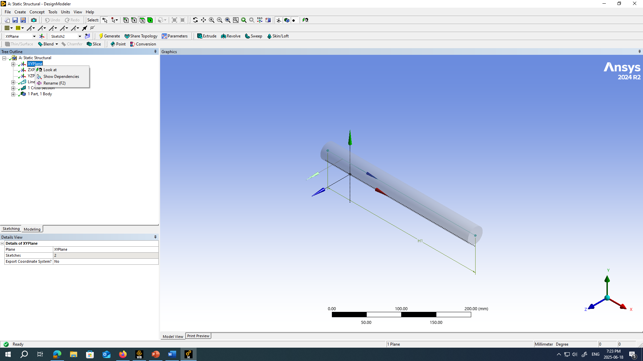

Real Geometry of 3D  
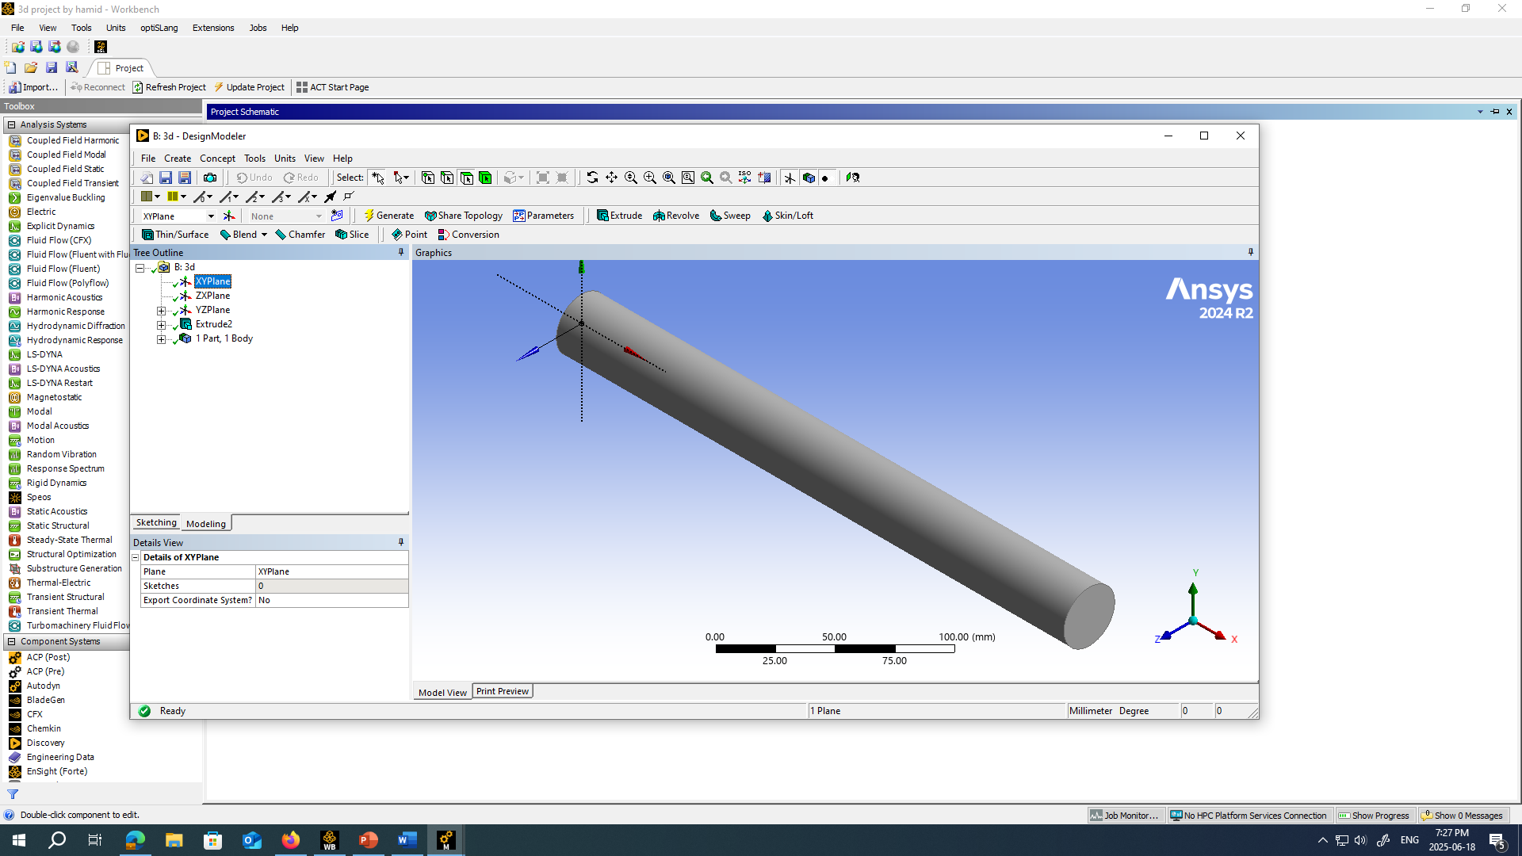

Step 4 Meshing of 1D Model   
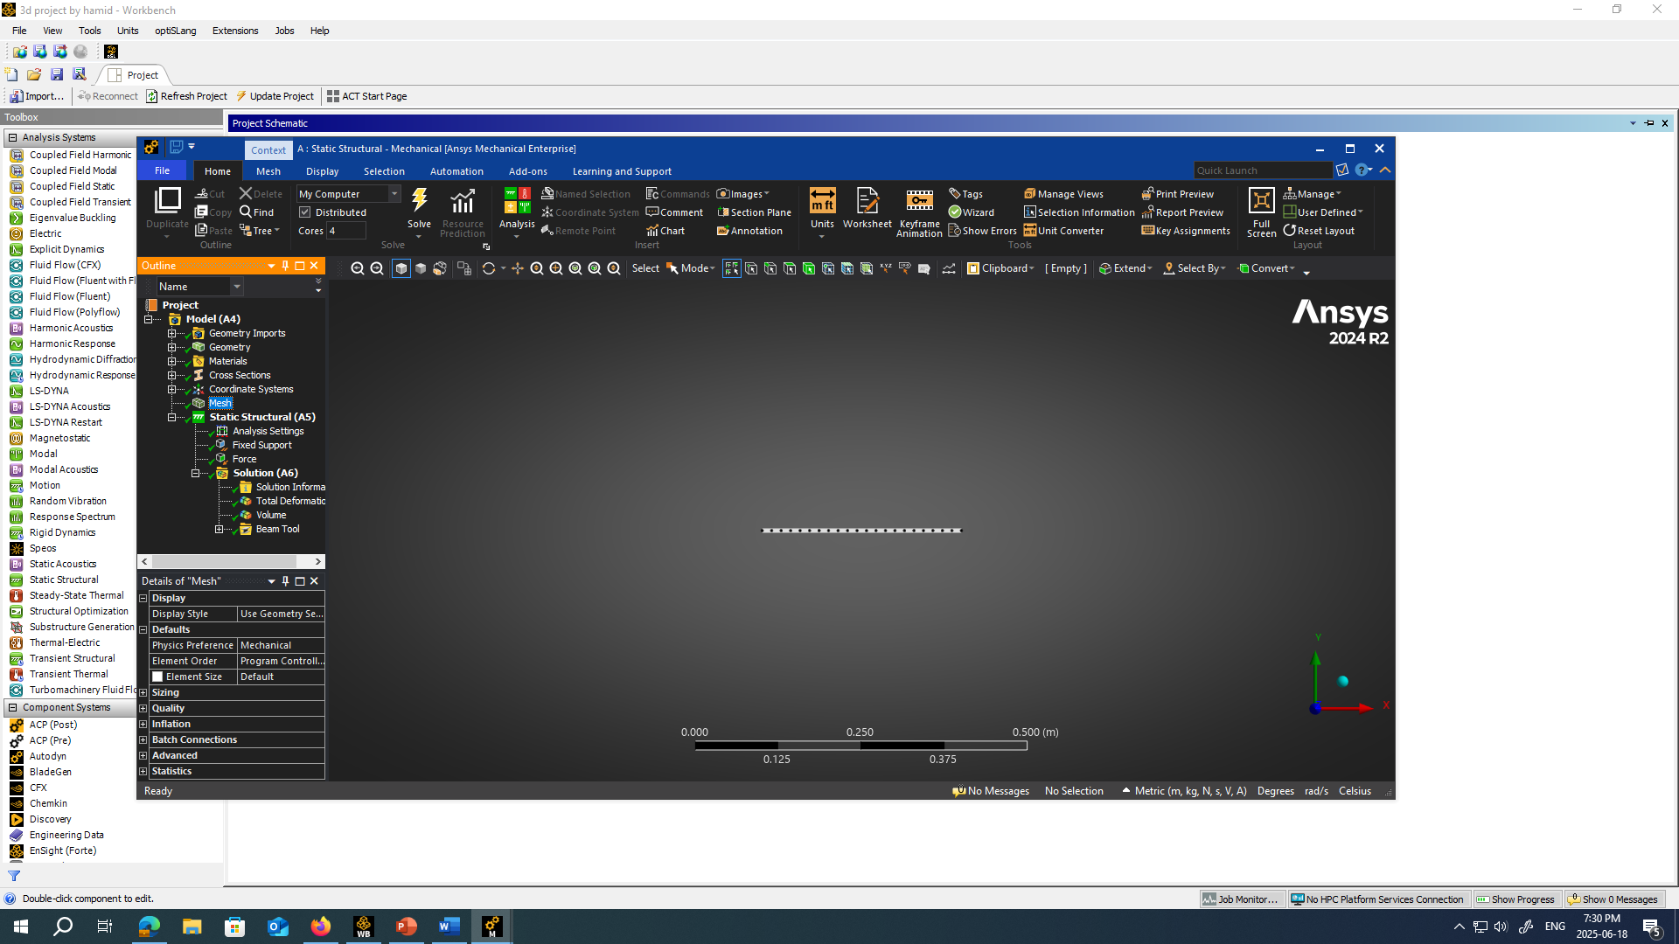  
  
Step 4 Meshing of 3D Model  
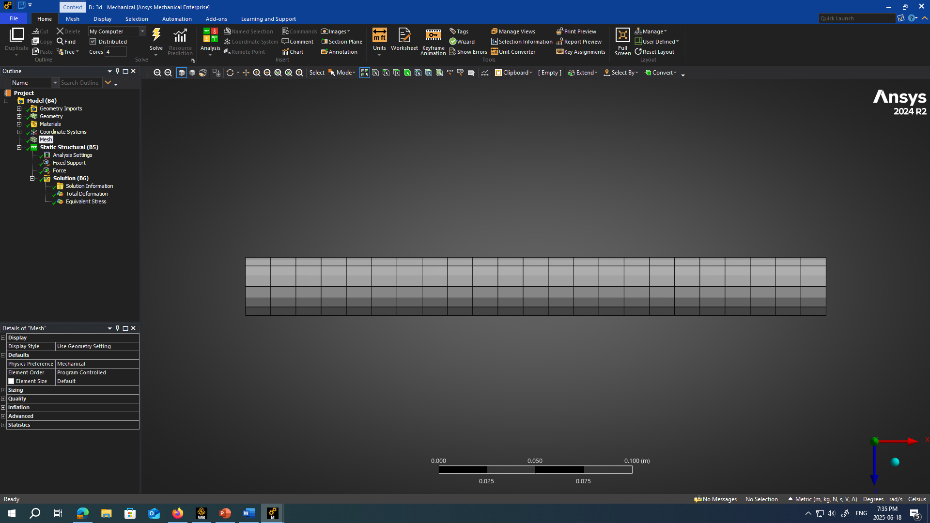

Step 5 setup for 1D  
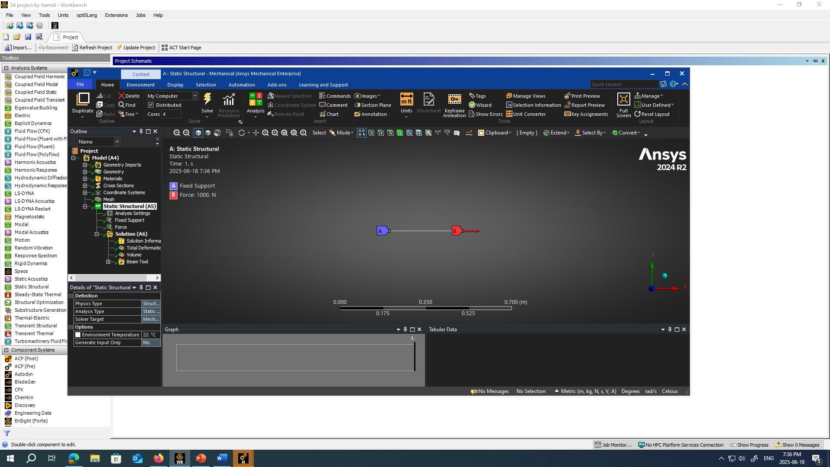

For 3D for Z-axis load  
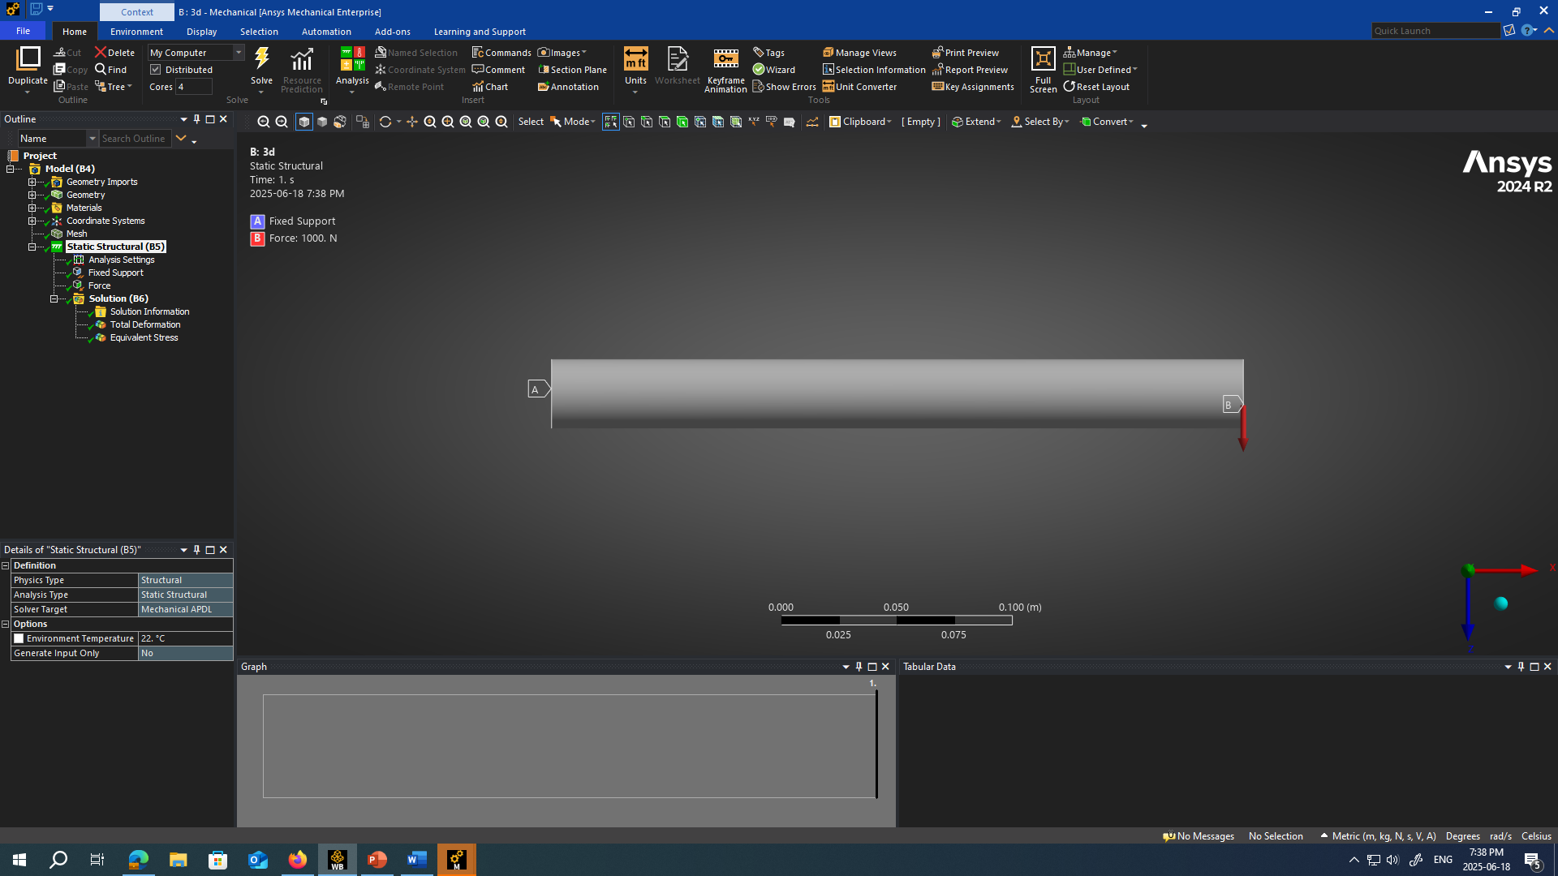

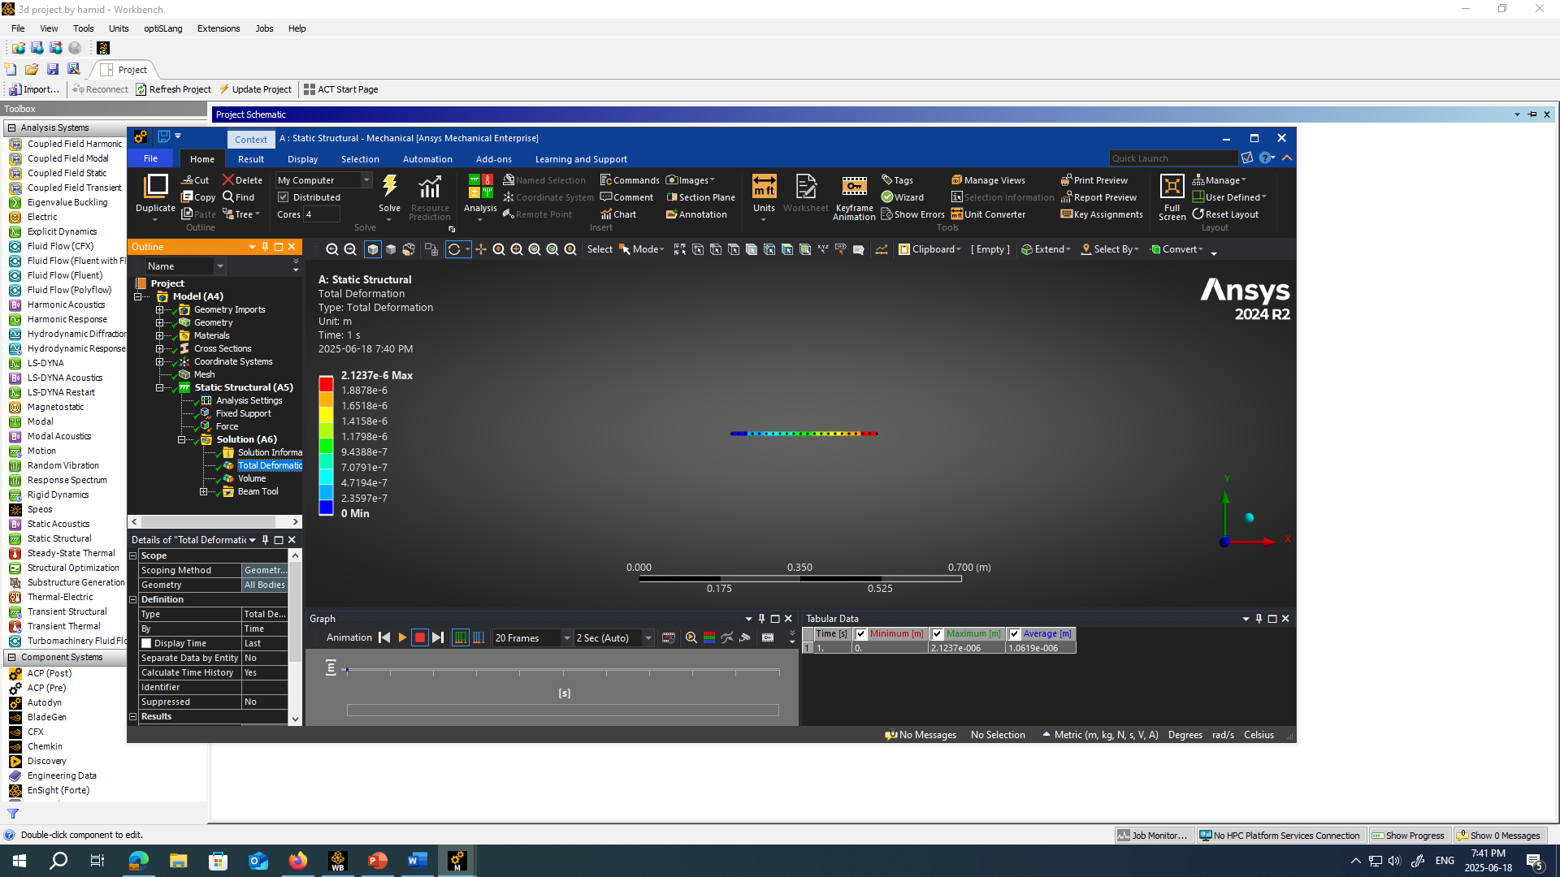Solution of 1D Total Deformation, minimum stress and direct stress

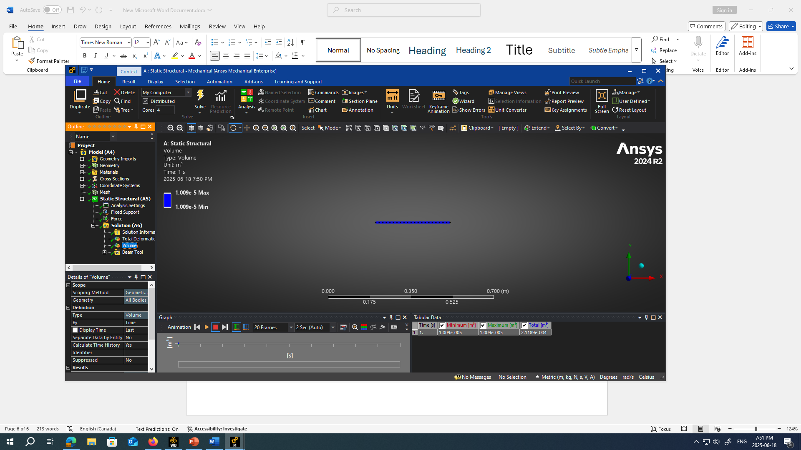

Solution of 3D

Total deformation in 1D 2x10^6

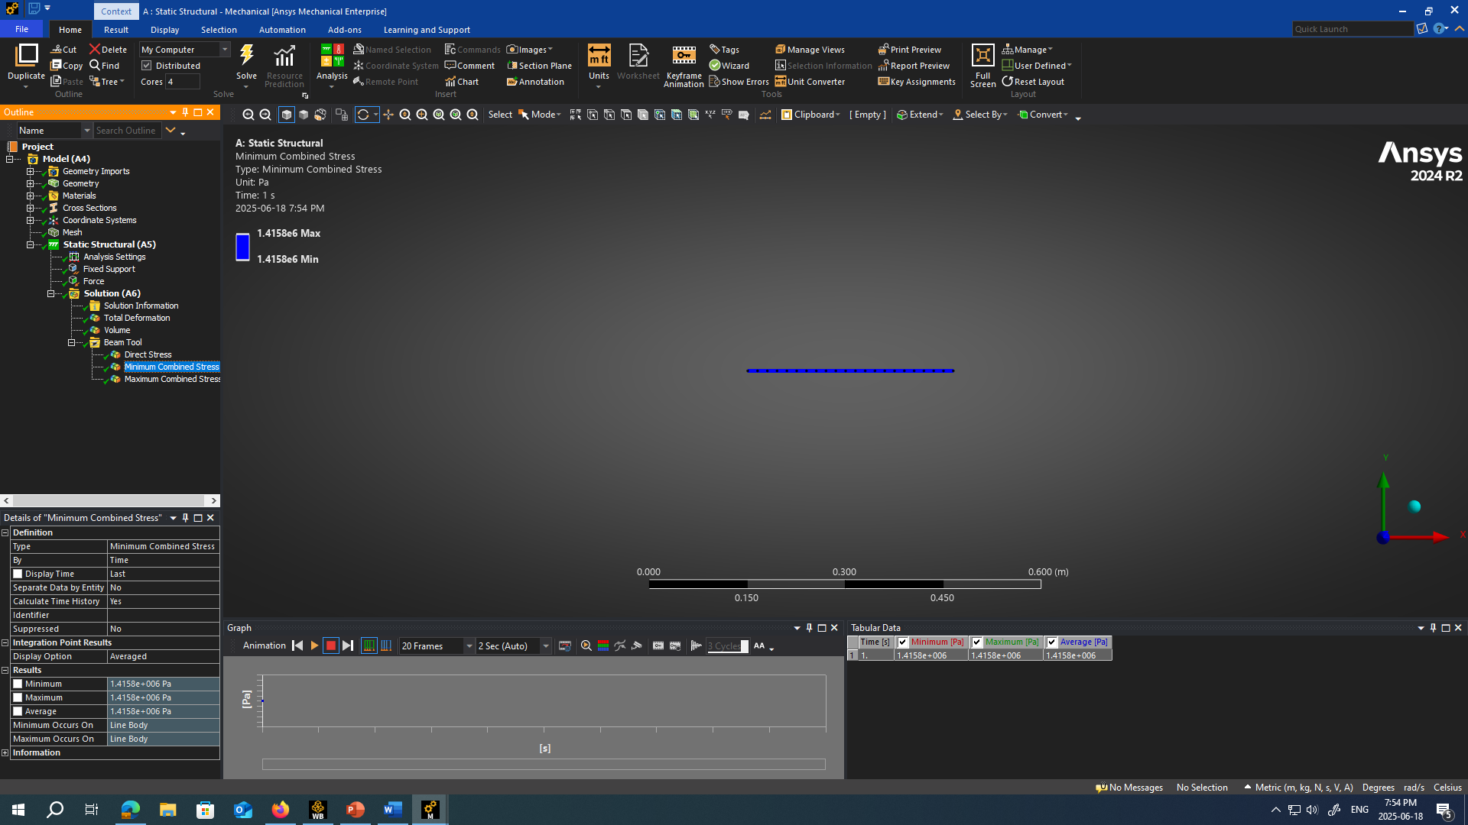

TOTAL DEFORMATION WITH TENSILE LOAD

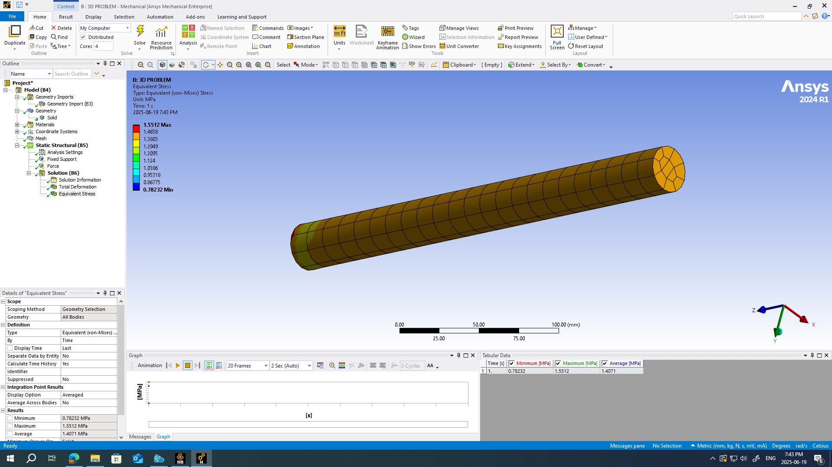

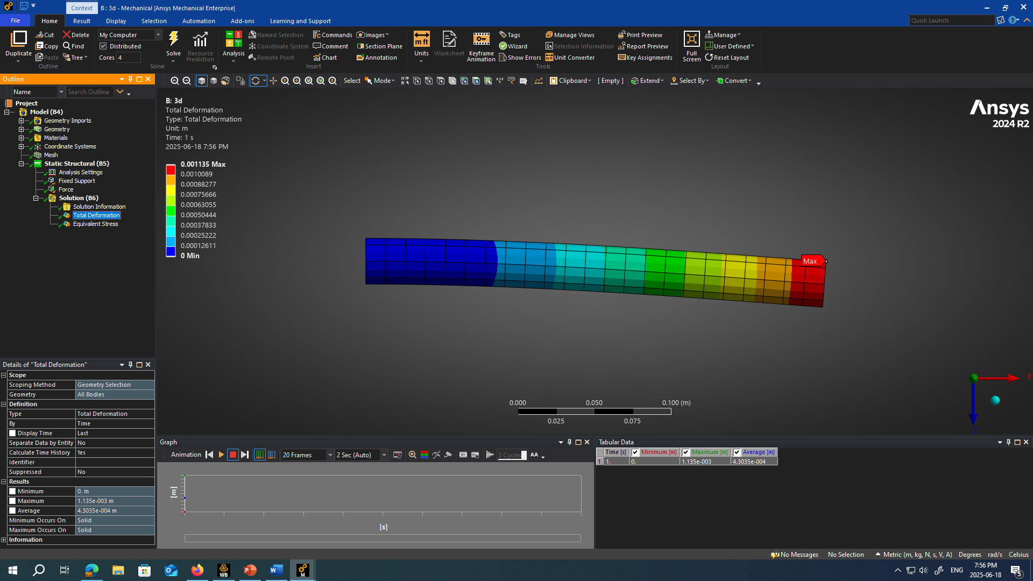Solution of 3D Total Deformation

